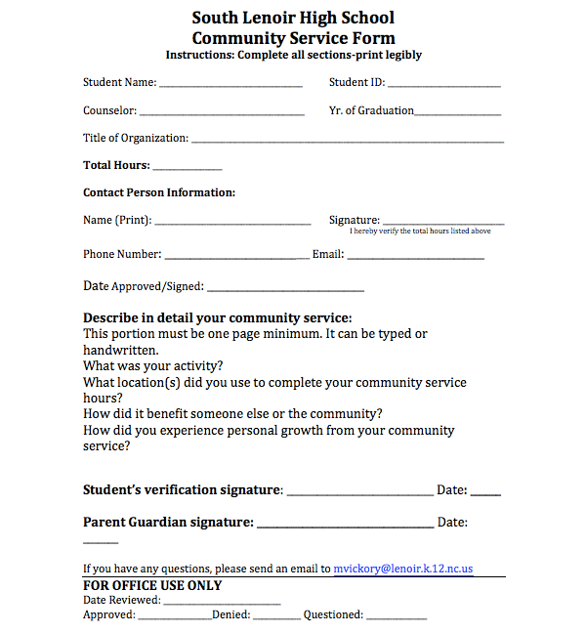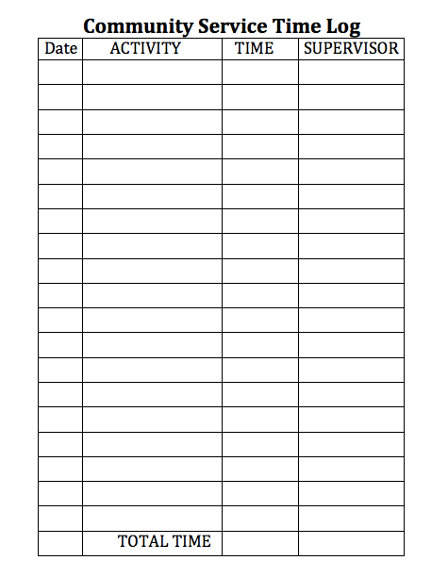

South Lenoir Class of 2019 Community Service

Also required to be included with your form and log is a minimum of 3 pictures of you performing your community service project.

All Community Service is Due No Later than 3:15pm on May 16th, 2019.

Early Graduates Community Service is due No Later than 3:15pm on November 30th.

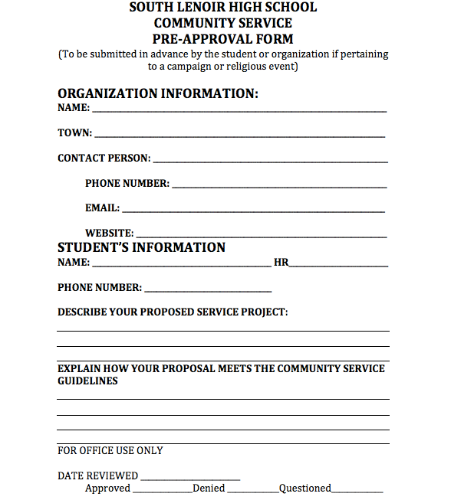

Pre-Approval Form

used only if pertaining to a campaign or religious event

Requirements

Definition of

Community Service

Community service is defined as an act or activity performed by an individual without compensation or required by the court system whose time and effort will benefit a person or group of people. The community activity must conform to the following guidelines:

* Student does not receive compensation for the activity. Examples include: court-ordered community service and activities where the student is paid for his/her service.
* The activity is not performed during scheduled school hours.
* The activity cannot be supervised by a parent or relative unless it receives prior approval from the South Lenoir Community Service Committee. Neither parents nor relatives may sign your logged hours unless prior approval is given from the South Lenoir Community Service Committee.
* Activities promoting religious ceremonies/events will be considered, but must receive prior approval from the South Lenoir Community Service Committee. The activity must impact individuals beyond the religious community.
* The activity must not be part of an assignment in which the student will receive an academic credit.
* Political campaigning or work benefitting political organizations will not be accepted.
* Fund raising for various clubs, organizations, sporting teams will not be accepted.

Each senior at South Lenoir High School is required to complete a minimum of 10 hours of community service beginning with the graduating class of 2016. This is a requirement for graduation. The community service requirement must be satisfied

one month prior to the graduation ceremony.



Process for Earning Community Service Hours

**Students may not begin accruing hours until the first day of their senior year of high school, unless otherwise approved by administration**. Hours can be earned by participation in a single activity or a combination of approved activities. These hours must be logged and approved by the supervisor of the service activity. The logged hours may then be turned in to the Counseling Center secretary where they will be documented.

Please refer to the Community Service Form and Community Service Time Log for documenting your hours. Both of these sheets are to be turned in to the Counseling Center secretary when you have completed your 10 hours. Community service hours must be completed one month prior to the graduation ceremony, with the exception of early graduates.