JMB Memorial Scholarship

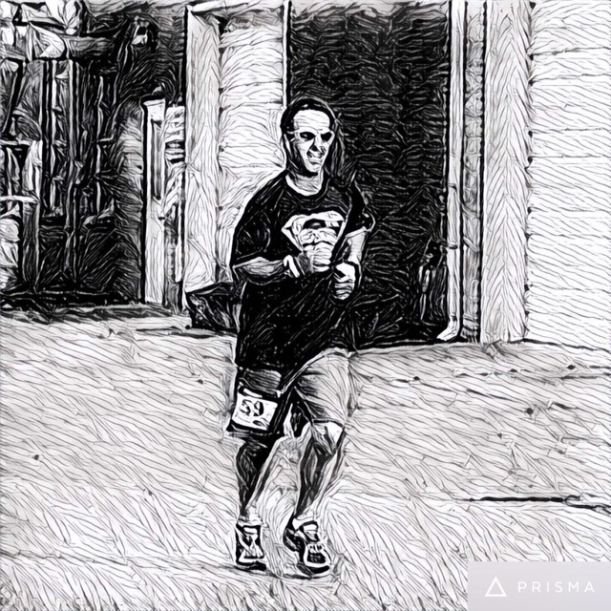

Joe Mike Baker was a dynamic man who loved his family, friends and community. A graduate of South Lenoir High School in 1992, Joe Mike enjoyed running, bowling, hunting, fishing, and travelling. His favorite past-time was the time he spent coaching kids in baseball and basketball. A social media legend, Joe Mike loved to make people laugh. He was a committed member of the Sandy Bottom community and would do anything in his power to help a neighbor. In his honor, this scholarship is given to a deserving student that will continue this passion and give back to their hometown community.

Criteria for selection:

- Applicants must be a South Lenoir High School Senior who plan to continue their education at a Community College.
- Applicants must have a GPA of 3.0 or higher
- Applicants must provide a letter of recommendation from a teacher, coach, or school administrator
- Applications must be returned to the school counselor by April 1st.
- Applicants must submit a 200 – 300-word essay answering:
“What your community means to you and how your education will contribute to your community?”
- Scholarship funds will be sent directly to the college of choice.

Applicant’s Full Name _____________________________________________________________________________________

Class of __________________________________

Address _____________________________________________________________________________________________________

______________________________________________________________________________________________________

Parent’s Name _____________________________________________________________________________________________

Phone Number _______________________________________ Date of Birth _________________________________

Weighted GPA __________________________

Which Community College do you plan to attend? ______________________________________________________

Please list the following:

Organizations, Clubs, Sports:

______________________________________________ _______________________________________________

______________________________________________ _______________________________________________

Academic Awards and Honors:

_____________________________________________ _______________________________________________

_____________________________________________ _______________________________________________

Talents, Skills and Hobbies:

_____________________________________________ ________________________________________________

_____________________________________________ ________________________________________________

Work, Volunteer and Community Service:

_____________________________________________ ________________________________________________

_____________________________________________ ________________________________________________

Career Objectives and Goals:

_____________________________________________________________________________________________________
_____________________________________________________________________________________________________

Applicant’s signature_____________________________________________________________________

