JMB Memorial Scholarship

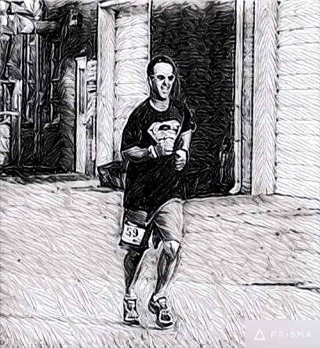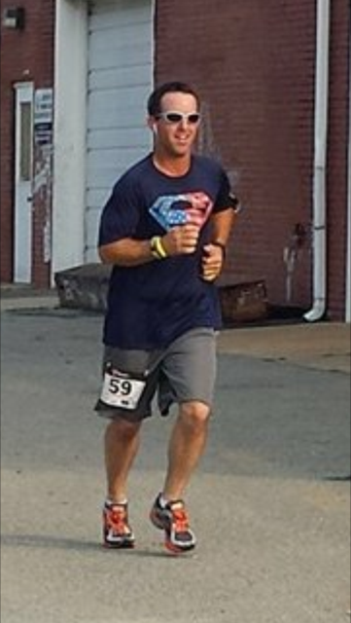

Joe Mike Baker was a dynamic man who loved his family, friends and community. A graduate of South Lenoir High School, Class of 1992, Joe Mike enjoyed running, bowling, hunting, fishing, and traveling. His favorite past-time was the time he spent coaching kids in baseball and basketball. A social media legend, Joe Mike loved to make people laugh. He was a committed member of the Sandy Bottom community (unofficial Mayor of Sandy Bottom) and would do anything in his power to help a neighbor. In his honor, this scholarship is given to a deserving student that will continue this passion and give back to their hometown community.

Criteria for selection:

- Applicants must be a South Lenoir High School Senior who plan to continue their education at a Community College.
- Applicants must have a GPA of 2.0 or higher
- Applicants must provide one letter of recommendation from a teacher, coach, or school administrator
- Applicants must submit a short essay answering:
“What My Community Means to Me and How My Education Will Contribute to My Community?”
- Applications and essays must be returned to the school counselor by April 1st.
- Scholarship funds will be sent directly to the Community College of choice and designated for books.

Applicant’s Full Name __________________________________________ Class of ___________________

Address ________________________________________________________________________________

Parent’s Name(s)__________________________________________________________________________________

Phone Number _______________________________________ Date of Birth ________________________

Weighted GPA __________________________Last 4 digits of Social Security #_______________________

Which Community College do you plan to attend? ______________________________________________

Please list the following:

Organizations, Clubs, Sports: Academic Awards and Honors:

_________________________________ ____________________________________
_________________________________ ____________________________________

Talents, Skills and Hobbies: Work, Volunteer and Community Service:

_________________________________ ____________________________________
_________________________________ ____________________________________

Career Objectives and Goals:
____________________________________________________________________________________
____________________________________________________________________________________

Applicant’s signature_____________________________________________________________________

