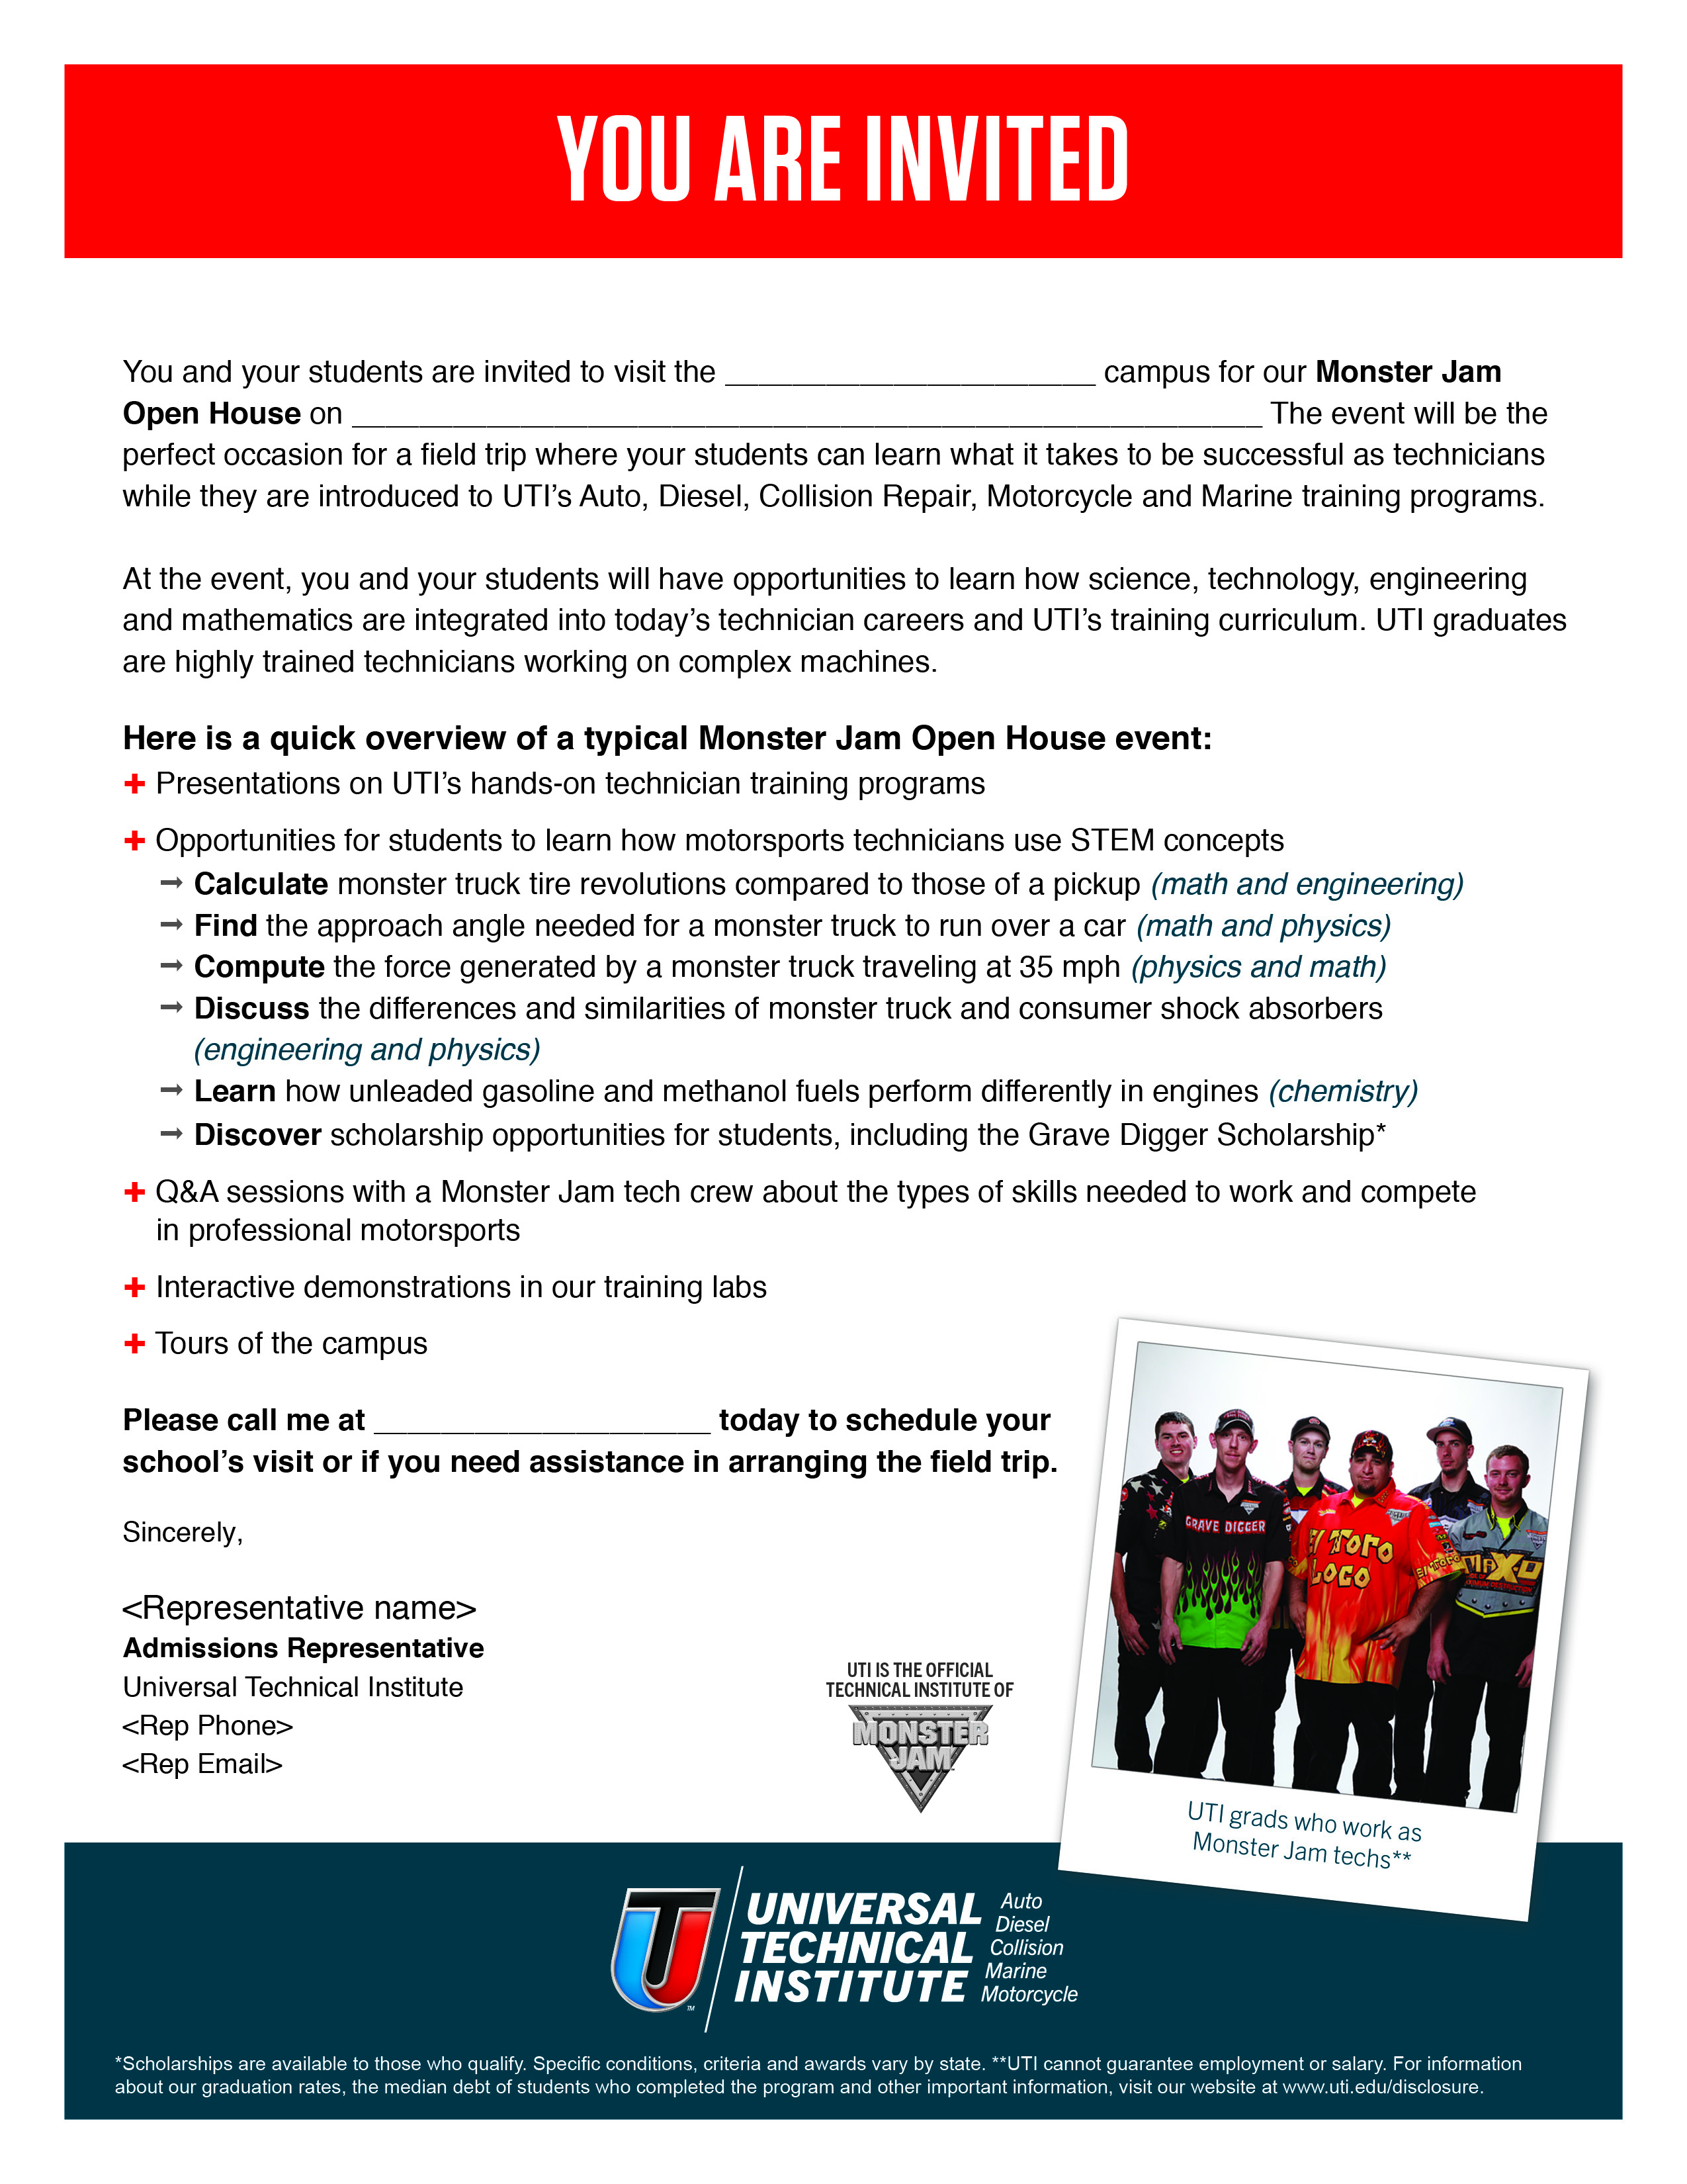

**UTI-Mooresville**

**RSVP Online:** [**uti.edu/MJOH**](http://www.uti.edu/MJOH)

Sincerely,

Dave Hettinger

**Admissions Representative**

Universal Technical Institute

252-414-0675

dhettinger@uti.edu

252-414-0675

**Friday, January 7, 2016, from 10:00 a.m. to 2:00 p.m.**