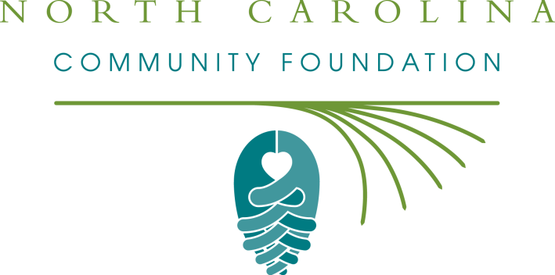

Attention Area SCHOOL Counselors!

The NCCF offers about 150 scholarships every year.
Many are available to students throughout the entire state,
and some may be available specifically for students in LENOIR COUNTY!

Please list us as a resource for your students
as they seek funding to support their academic futures.
Our website contains information about applying for our scholarships.
Our list of available scholarships is updated every February.
You can find us at:
http://nccommunityfoundation.org/Scholarships

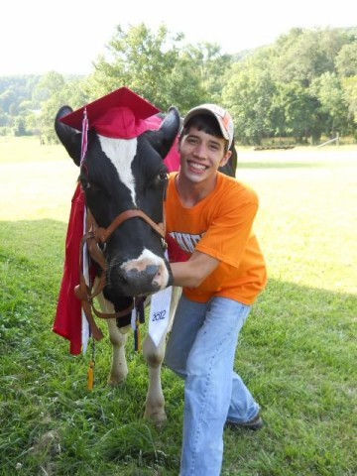
If you have additional questions,
please contact:
Kim Ball, NCCF Regional Director
kball@nccommunityfoundation.org
252-670-5929
Or
Sybil Bowick, NCCF Scholarship Specialist
sbowick@nccommunityfoundation.org
919-256-6929

______________________

Lenoir County offers The Kathleen Morrisey Klutey Memorial Scholarship Fund
“Without scholarships like these, I wouldn't be able to achieve my education, my goal, or my believed life's destiny.” – Caitlyn Bodo, NCCF Scholar
“The standard and drive to excel is even held higher to me because the people behind this scholarship believe in me and have supported me throughout my college education.” – Katelyn Yarborough, NCCF Scholar

